Chapter 19, Solution 91

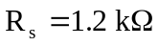, 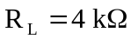

- 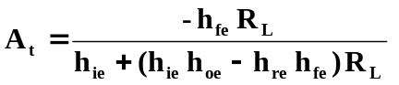
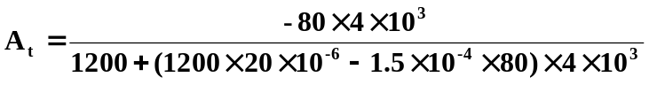
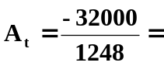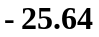 This is just the gain for the transistor. If we calculate the gain for the circuit we get A_{t} = V_{o}/V_{be} and V_{be} = V_{s}[1.2k/(1.2k+2k)] = 0.375, thus, V_{A} = (0.375)(–25.64) = –9.615.

- 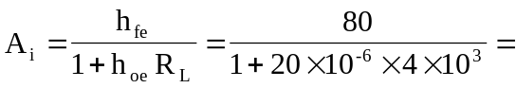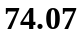

- 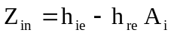
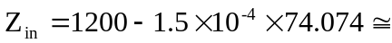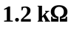

- 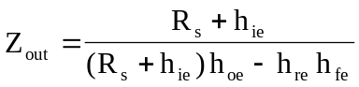
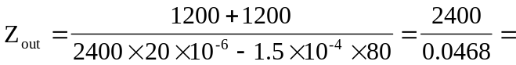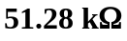

(a) –25.64 for the transistor and –9.615 for the circuit, (b) 74.07, (c) 1.2 kΩ, (d) 51.28 kΩ

